Component diagram
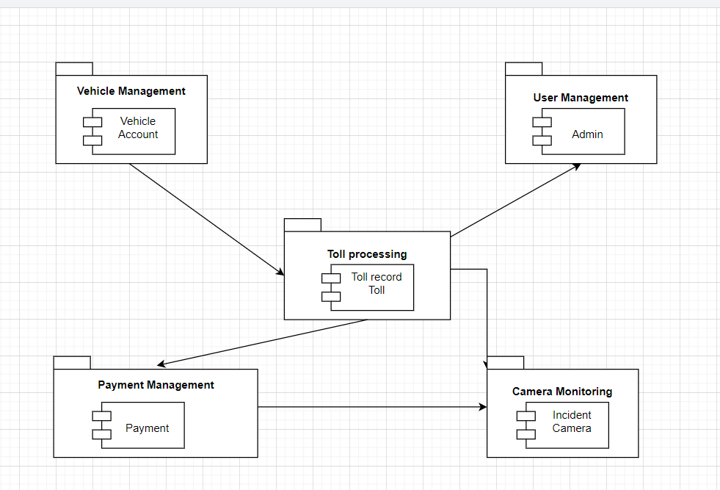

This component diagram models a Toll Management System and illustrates how different functional modules (subsystems) interact with each other. The diagram is divided into several key subsystems, each responsible for specific features in the system. These components are visualized as rectangular boxes containing smaller component symbols (interfaces), and arrows denote dependencies and interactions between them.

Subsystems and Components:
- Vehicle Management System
Component: Vehicle,
This component handles all information related to vehicles using the toll system. It manages vehicle registration, license plate details, and links vehicles to user accounts.
- User Management System
Component: Admin
Responsible for managing administrative users of the system. This component includes admin roles, authentication, and access control for managing other subsystems.
- Toll Processing Subsystem
Components: TollRecord, Toll
The core module of the system. It records vehicle passages through tolls, generates toll records, calculates toll fees, and determines the toll location and time. It receives data from vehicle and camera systems and forwards information to payment and monitoring subsystems.
- Payment Management Subsystem
Components: Payment, Camera
This component handles all payment operations including toll fee calculation, payment processing, and integration with external payment systems. It also processes camera data (used for violations, license plate capture, etc.) and links payments to toll records.
- Camera Monitoring Subsystem
Component: Incident
Manages monitoring through cameras installed at toll gates. It detects and logs incidents such as unpaid tolls or rule violations. It integrates with the payment and toll processing systems to take necessary action based on the incident data. It also processes camera data (used for violations, license plate capture, etc.) and links payments to toll records.

Interactions Between Components:
- The Vehicle Management subsystem provides vehicle data to Toll Processing so that tolls can be linked to specific vehicles.
- The User Management subsystem interacts with Toll Processing to allow admins to access and manage toll records and operations.
- The Toll Processing subsystem sends toll information to the Payment Management system for billing and transaction purposes.
- Camera Monitoring receives incident and toll data from Toll Processing, and also interacts with Payment Management for violation payments.
- The Payment Management system also utilizes Camera components to verify license plates or violations linked to payments.

